Regional Water Quality Sampling

Purpose

The regional water quality sampling project began in 1999 with an EPA order for various municipalities in the Phoenix metropolitan area to address taste and odor issues that were plaguing the regional water supply. The compounds of concern were identified as 2-methylisoborneol (MIB) which causes as musty odor, and Geosmin which causes an earthy taste. Both compounds are released by algae that grows in the reservoirs and canals that compose the region’s surface water supply, especially during summer when abundant sunshine and warm temperatures promote algal blooms. Complaints from water utility users were so numerous that the issue had to be addressed. Although these compounds do not cause any health problems, they create foul odor and taste which causes users to lose faith in their water utilities and question the reliability of the treatment process. Both chemicals can be detected in concentrations as low as 10 ng/L and during peak summer algal blooms this concentration is regularly exceeded.

The project has been ongoing since 1999, providing valuable data to the region’s water utilities about the water supply. The project data has been used in a variety of other projects examining topics ranging from disinfection by-product formation to invasive species infestation. Initially managed by the Westerhoff Group at Arizona State University, today the project is run by Dr. Peter Fox and Dr. Morteza Abbaszadegan.

What Parameters Do We Test?

As part of the Regional Water Quality Sampling Project the following tests are performed:

* UV254 Absorbance to look for natural organic matter – Your Responsibility
* DOC (Dissolved Organic Carbon) – Your Responsibility
* *E. coli* and fecal coliform count – Your Responsibility
* *Mycobacterium* count – Your Responsibility
* TDN (Total Dissolved Nitrogen) – This test is run by Cathy Kochert in the Goldwater Environmental Lab at the Goldwater Center (GWC).
* MIB (Methyl Isoborneol) and Geosmin – This test is run by Marisa Masles in the Goldwater Environmental Lab at the Goldwater Center.
* Turbidity and Conductivity – This test is run by Marisa Masles during her reservoir sampling.
* ICPMS to look for trace metals – This test is run by Marisa Masles in the Goldwater Environmental Lab at the Goldwater Center. This is done during quarterly sampling.
* Sucrose- This test is run by Marisa Masles in the Goldwater Environmental Lab at the Goldwater Center. This is done during quarterly sampling.

Sampling Locations

The map of our sampling locations can be seen in the attached .kmz google earth file. It is a good idea to download the .kmz file onto your phone so you can use your GPS. Otherwise it is a good idea to print out google driving directions. Here are written descriptions of the location of each site and anything else you should know about them:

* PIMA (AZ Canal at Pima Road) – Located at the canal crossing with Pima Road 1 mile north of McDonald Drive on the west side of the road near the bridge. There is a pull out near the golf course.
* 56th- (AZ Canal at 56th Street) – Located at the northeast corner of 56th St. and Indian School Road. Take the sample near the pipe.
* CENT (AZ Canal at Central Avenue) – Located at Central Avenue and Orchid Lane (north of Northern Ave 2 miles). There is a pull off for the bike path on the west side of the road.
* UH IN/OUT (Union Hills WTP Inlet and Treated)- Deer Valley Road and 21st St. (West of Cave Creek Road). Take In sample from “Raw Water Influent” tap, take Out sample from “Ent Point Distribution System” tap, both located in the operators lab in Building 9.
* AN IN/OUT (Anthem WTP Inlet and Treated) – Located at Gavilan Peak Pkwy and King Drive (off Daisy Mountain Dr. Exit of I 17). Influent sample taken from raw water screen. Effluent sample taken from the permeate room.

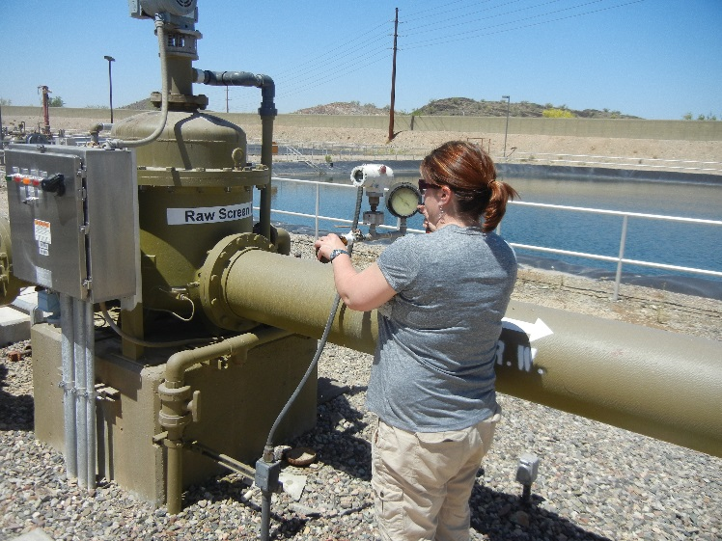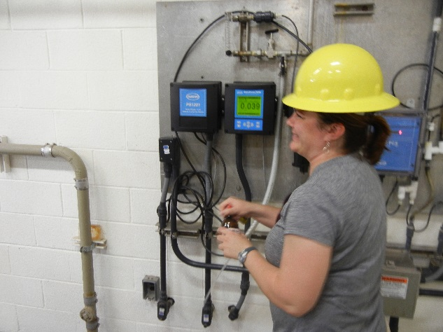

* R3 (Waddell Canal) – Located off Carefree Highway Rt. 74 exit of I 17 west of Lake Pleasant Parkway. From Highway 74 take a left onto Lake Pleasant Parkway and then turn right onto Old Highway 74 near the glider school. The site is on the right hand side of the road before the crossing.
* GR IN/OUT (Greenway WTP Inlet and Treated) – Located at 75th Avenue and Greenway Road. Take In sample from “Raw Water”, take Out sample from “Filt Eff”. Be sure to collect this sample by 10 AM to avoid arriving while the system is down (they flush on Monday mornings around 11 AM).
* GL IN/OUT (Glendale WTP Inlet and Treated) – Located at Cholla Street and 49th Avenue. Take In sample from “Raw Influent”, take Out sample from “BVS”, both in the operators lab.
* NP IN/OUT (Tempe North WTP Inlet and Treated) – Located at 68th Street and Marigold Lane, take the inlet sample from the canal flowing into the treatment plant and the effluent sample from the blue pipe located near the canal.
* SPT IN/OUT (Tempe South WTP Inlet and Treated) – Located Off of 101 south of Guadalupe. Take the samples from the operators lab.
* CH IN/OUT (Chandler WTP Inlet and Treated) – Located off of Pecos Road and 124th St. Take the samples from the operators lab.
* MOC (Middle of Consolidated Canal) – Located at Lindsay Road north of Juniper Avenue. There is a pull off of Lindsay Road on the Right Side where the canal crosses the road.
* HTC (Head of Tempe Canal) - Located east of Mesa Dr. and Brown Road. Turn onto the canal service road and take the sample midway along the canal.

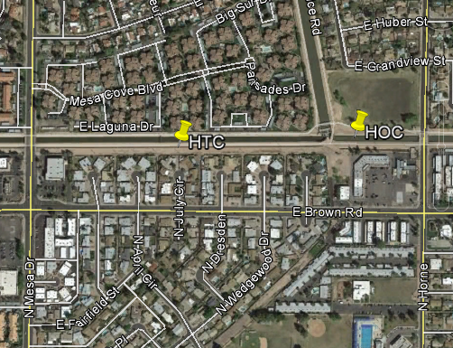

* HOC (Head of Consolidated Canal) - Located West of Horne and north of Brown Road. Take the sample just past the turn in the canal.
* R10 (Salt River at Blue Pt. Bridge) – This sample is taken at the Blue Point Recreation Site on Bush Highway (east of Usery Pass Rd.)

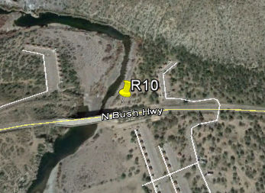

* R11 (CAP Canal at Cross Connect)- Bush Highway and Granite Reef Dam Road. Use your Key to open this gate.

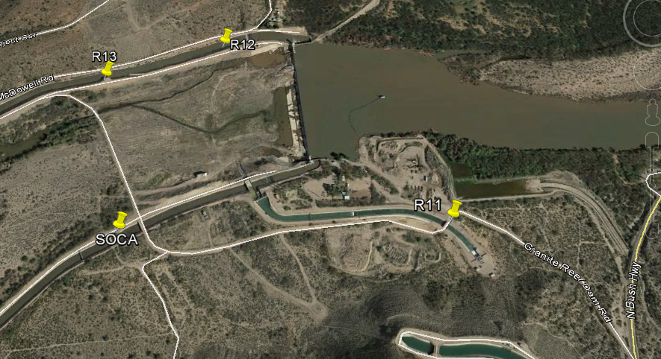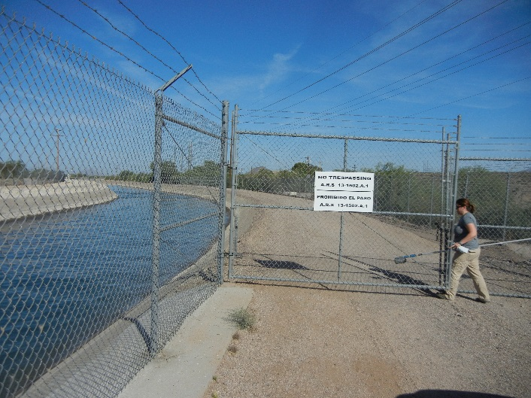

* SOCA (South Canal below CAP Cross Connect) – Located in the Granite Reef area at the vehicle bridge over the South Canal before crossing the wash. You will need Jeff to unlock the gate to get access to this site.

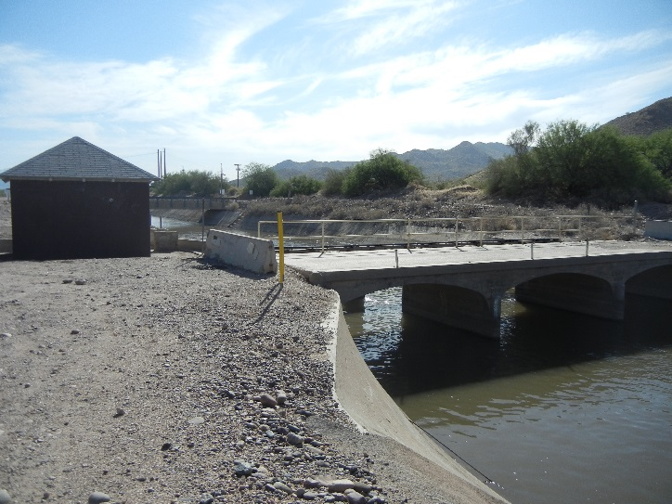

* R12 (AZ Canal Above CAP Cross-Connect)- Granite Reef area, just west of waterfall area with high voltage signs at guard rail (just thru gate). You will need Jeff to unlock the gate to get access to this site.

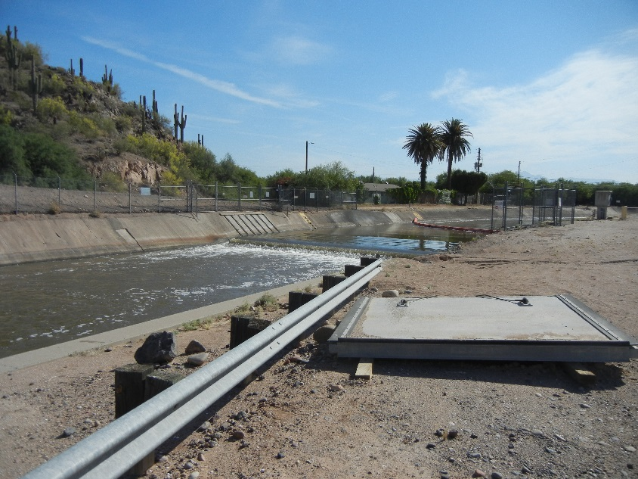

* R13 (AZ Canal Below CAP Cross-Connect) - Granite Reef area, boat launch ramp area west of R12. You will need Jeff to unlock the gate to get access to this site.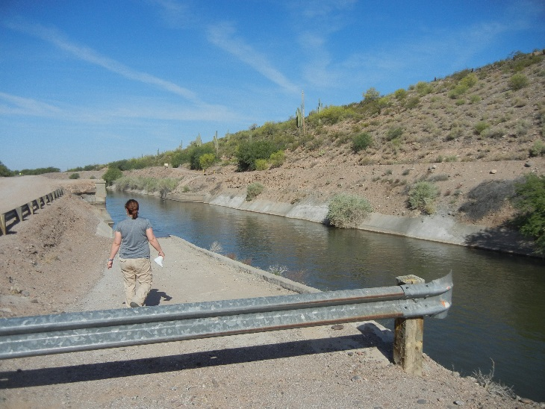
* HWY 87 (AZ Canal at Highway 87) - Located on canal service road east of HWY 87 at boat ramp east of val vista drive. You will need Jeff to unlock the gate to get access to this site.

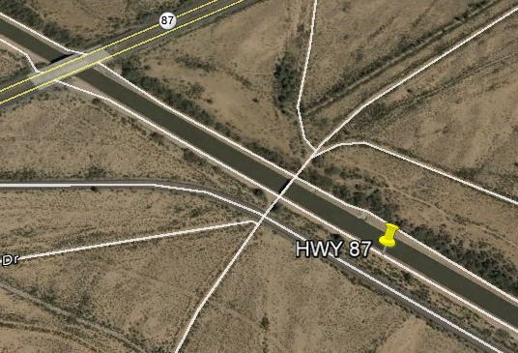

* R20- Pick up from USGS (SE-corner 52nd St. and University) monthly
* R25 (Verde River at Beeline Highway) - Verde River north of HWY 87 east of Fort McDowell Rd. Watch out for the pitbull and the cows.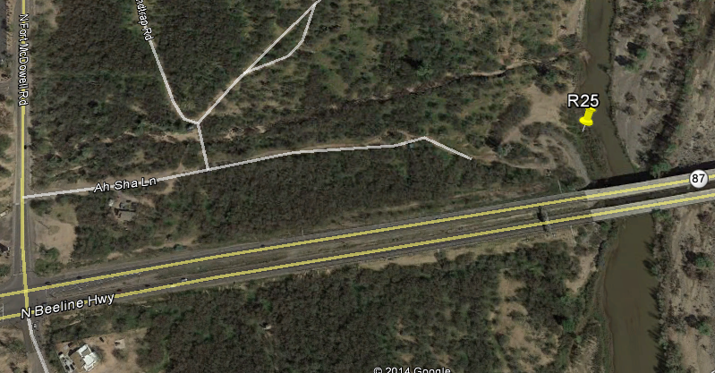
* HAV/R2A/R2B/SGPS/MTO - Pick up monthly from CAP (7th St. N of Pinnacle Peak Road)
* R6A/R6B/R9A/R9A-Dup/R9B – Pick up Monthly from GWC 673 Cold Room. Marisa Collects these.
* ISTB4- Take a sample from the tap in the sink next to bench
* ROOS/APA/CAN- Pick up from Marisa in GWC 673 cold room (quarterly samples)

Dropbox Log-in Credentials

To access the database of historic data you will need to log into our dropbox account at dropbox.com.

<http://www.dropbox.com>

Log-in Email Address: [tasteandodor@gmail.com](mailto:tasteandodor@gmail.com)

Password: westerhoff

Necessary Training

The following training must be completed prior to authorization to work on the project:

* Laboratory Safety (In person)
* Defensive Driving (Online and in person section)
* Compressed Gas (online)
* Biosafety and Bloodborne Pathogens (online)
* Hazardous Waste Management (online)
* Fire Safety (online)

You can access the training modules here: <https://cfo.asu.edu/ehs-training>

ISAAC Access

Access to the laboratories must be requested via the ISAAC access system. This will need to be renewed on an annual basis.

Request access here: <http://ssebe.engineering.asu.edu/research/isaac.html>

Preparation

Ashing Glassware/DOC Vials/Filters

Prior to use in sample analysis, any materials used for carbon and organics procedures must be ashed to remove any trace carbon present. This is completed by placing the materials into a furnace and heating to 600 Celsius, which burns off any carbon present. This allows us to be certain that any carbon detected during total organic carbon analysis or UV 254 analysis was introduced from the environment and not some other source of contamination. Objects that should be ashed include 40 mL vials, DOC vials for the TOC analyzer, and Glass Filters for sample processing.

To ash your materials:

1. Wrap the materials in aluminum foil. Make sure that everything is completely covered so that it will not become contaminated after removal from the furnace. Filters can be ashed by placing 50 or so in an envelope made by folding aluminum foil (they do not have to be individually placed).
2. Place wrapped materials into the furnace located in the LER. Ensure that the door is able to close without obstruction. Close the door and lock into place by turning the handle
3. Press the “run” button once. You should see a program pop up. Press the “run” button again. You will hear a click. The furnace will automatically heat to 600 Celsius and cool off. Do not open the furnace door if the internal temperature is more than 100 Celsius. This will result in glassware shattering due to rapid temperature change.
4. Once materials have cooled bring them back to the lab and place them in a safe place.

Autoclaving Microbial Bottles

Bottles used for microbial samples must be autoclaved prior to use in order to sterilize them. This ensures that all microbial colonies detected during sampling are actually coming from the sample and not just from contamination in the bottles. The autoclave is located in ISTB4 Lab 321. To autoclave the bottles follow this procedure:

1. Check to make sure that what you are autoclaving is actually autoclavable. Using non-autoclavable bottles will result in them melting and possibly damaging the autoclave.
2. Loosen caps on the bottles so that they are only tightened a quarter turn. If the caps are too tight the change in pressure in the autoclave will result in rupturing of the bottles.
3. Place a strip of autoclave tape over the top of the bottle/cap to ensure that the cap does not fall off the bottle. The autoclave tape will turn black upon completion to help you verify that the proper temperature for sterilization did actually occur.
4. Check to make sure autoclave is at proper water levels. There should be water inside the bottom of the autoclave and the water tank should have a level between “low” and “high”.
5. Place bottles in the basket and place inside autoclave. Secure the lid by locking the latch.
6. Select “solid” mode and ensure that temperature is set for 121 C and time is set for 15 minutes. Autoclaving takes approximately 1.5 hours.
7. Remove objects from autoclave and secure lids. Store in a place where no one will “mistakenly” steal sterilized bottles.

When Dr. Abbaszadegan’s autoclave is not working you will have to use the floor autoclave located in the 3rd Floor LER. You will need to gain access to the google calendar for this autoclave in order to reserve a time. You can email Stan Klonowski to be added to the calendar. To operate this autoclave:

1. Press Log in and input the user name “SSEBE” and password “CESE”.
2. Click “Select Cycle” and select the appropriate cycle (Hard Goods Default for solid bottles and sampling supplies and 15 Minute Liquid Default for agar, media, or anything else liquid)
3. Place your materials in the autoclave and push “System On/Off” to turn the autoclave on.
4. Push and hold “Door Close” and Push “Start” to begin
5. After about an hour and a half the cycle should be completed and you can remove your materials by pressing “Door Open”. Be Careful to avoid getting burned by any steam remaining in the autoclave.

Preparation of Microbial Media

We need to make two types of media – Brilliance for coliform and *E. coli* detection and 7H11 for mycobacterium detection. Each plate should have 15-20 mL of media in it to avoid drying out during incubation.

To make Brilliance media:

1. Figure out how much media you will be making. You can make up to 2 months of media at a time. Each site where microbial measurements are taken (Pima, 56th, Cent, R3, HOC, HTC, MOC, R11, R12, R13, HWY 87, and R25) needs its own plate.
2. Measure out the required volume of water. You will need to use DI water.
3. Pour water into a flask place on hotplate and begin heating. Add a magnetic stirrer and mix.
4. Measure out the media (the side of the bottle has the required ratio of media to water).
5. Add the media and cover the flask with aluminum foil.
6. Once the solution is boiling and clears up turn off the heat.
7. Cool the media down to 50 C (approximately when you can touch the glass without burning your hand).
8. Turn on a Bunsen burner and allow it to run. Using a 25 mL serological pipette fill each plate with 15ish mL of liquid media. Allow media to cool on benchtop.
9. Once media is cool and has solidified place the plates in a bag and label with your name, media type and date. Store lid side down in the fridge until use is required.

To make 7H11 media:

1. Figure out how much media you will be making. You can make up to 2 months of media at a time. You will need 1 plate for every 2 sampling sites.
2. Measure out the required volume of water. You will need to use DI water.
3. Pour water into a flask place on hotplate and begin heating. Add a magnetic stirrer and mix.
4. Measure out the media (the side of the bottle has the required ratio of media to water).
5. Add the media and 1 mL of 50% glyceryl solution for every 100 mL of solution and cover the flask with aluminum foil.
6. Once the solution is boiling and clears up turn off the heat.
7. Take the solution along with another flask filled with 100 mL DI water to the autoclave and autoclave on the 15 min liquid default cycle.
8. Once autoclave is complete bring the solution back to the lab and place it on a mixer. Add 10 mL of OADC growth supplement (kept in the fridge) for every 100 mL of solution. Transfer 10 mL of autoclaved DI water into 1 vial of Panta BBL Antibiotic (also kept in fridge) mix and add to solution for every 100 mL of solution. Mix thoroughly
9. Turn on a Bunsen burner and allow it to run. Using a 25 mL serological pipette fill each plate with 15ish mL of liquid media. Allow media to cool on benchtop.
10. Once media is cool and has solidified place the plates in a bag and label with your name, media type and date. Store lid side down in the fridge until use is required.

There is an attached excel file with media preparation instructions as well.

Key Pickup

The Key for the SSEBE Department Pickup Truck is located at the receptionist desk on the 5th floor of College Avenue Commons or in Ray Murdock’s office in CAVC 527 (Located just north of College and University). The receptionist desk is located directly off of the elevator on the 5th floor. The key can be picked up on Friday afternoons anytime between 2:30-5 PM or on Monday mornings starting at 8 AM. It is a good idea to pick up the key on Friday afternoon if you would like to get an earlier start. If you need to contact someone to change your schedule email Ray Murdock ([Ray.Murdock@asu.edu](mailto:Ray.Murdock@asu.edu)).

When you arrive you will need to fill out the “pink sheet” that the receptionist will give you. It just asks for your contact information, student ID number, number of passengers, etc. Have you ID number and driver license on hand to fill out the form.

The key will come attached to a small clipboard with a form that includes the mileage and time at checkout and check-in. Be sure to fill out the truck mileage prior to departure. The key wallet also has a gas card that you can use to refill the tank. The truck must always be returned with more than ½ tank.

Scheduling of the truck use is typically done at the beginning of January for the year. Contact Ray Murdock and email him the sampling schedule to reserve the truck. The sampling schedule should have the first Monday of every month as well as the 3rd Monday of the month from June to the end of October. To set the sampling schedule meet with Dr. Fox and Dr. Abbaszadegan.

Glassware Pickup

Glassware for monthly sampling is prepared by Marisa Masles and placed in a wheel cooler in GWC 673 in the cold room. You will need to request ISAAC access to enter this room. The cooler and glassware is usually available on Friday afternoons after 3 PM. You can contact Marisa via email to check if it is ready for pickup ([marisa.masles@asu.edu](mailto:marisa.masles@asu.edu)). After picking up glassware you can leave it in the high bay at ISTB4.

TDN Scheduling

Dr. Fox’s TOC analyzer does not have the capability to perform Total Nitrogen analysis so we send our samples over to the Goldwater Environmental Lab to be analyzed for Total Nitrogen. You should contact Cathy Kochert ([cathy.kochert@asu.edu](mailto:cathy.kochert@asu.edu)) to schedule a TN run. It is best if you can contact her at least 1 week prior to running samples to ensure that she will be able to run our samples in time to get the data to Dr. Fox for the newsletter. TN runs should be scheduled for the day after TOC is run because Cathy needs the filtered 40 mL vials. Drop off the 40 mL vials in GWC 673 by 9 AM on the morning of the scheduled TN run.

Ordering Supplies for Future Work

Whenever supplies need to be ordered you will need to fill out an order form and email it to Ray Murdock with Dr. Fox and Dr. Abbaszadegan CC’d on the email. They will need to approve the order. I have saved all of my old order forms in the folder so you can see the supply orders as an example. You can also use them to reference the product codes. You should check your supplies every month to make sure you have enough for the next month and place the order in time to get everything in before you need it next.

The only thing that you cannot order via the supply order form is the gas cylinders, which will need to be ordered by Dr. Fox or Dr. Abbaszadegan via the Sunrise system. When the gas cylinder is approaching 500 psi, email Dr. Fox and ask him to place an order for Air Ultra Zero Grade USP. The cylinder will be able to be picked up in the cylinder cage.

Sampling

Checklist

By Friday afternoon before sampling make sure the following has been done:

* Ash vials and filters including (40 mL vials, DOC vials, UV 254/DOC Filters)
* Autoclave Microbial Bottles and Membrane Filtration Cups
* Have Media Prepared for microbial tests (Brilliance and 7H11)
* Pick up Truck Keys from Ray
* Pick up Cooler from Marisa
* Call Jeff Conyers with SRP to make sure someone is available to open the gate on Monday

On Monday prior to leaving for sampling make sure you have:

* Glassware cooler with glassware
* Ice packs (obtained from Westerhoff fridge on 3rd floor LER in ISTB4)
* Truck Key (fill out the mileage before you leave)
* Sampler (pool skimmer pole with duct-tape Nalgene jar, extremely hi-tech)
* Autoclaved Microbial Bottles
* Gate Keys

After you finish sampling for the month check your supplies to make sure that you have enough:

* Membrane Filtration Filters
* UV 254/DOC Filters
* Labeling Tape
* Microbial Media (Brilliance, 7H11, OADC Growth Supplement, Panta BBL)

If you do not have enough of these things for the next month make sure that you place an order right away so that you can have these supplies in time for the following month’s sampling event.

Sampling Order

There is no specific required order to retrieve most samples. However, due to some time constraints it is a good idea to retrieve the following samples first:

* Samples from Granite Reef Dam must be picked up at the time that Jeff Conyers (SRP) is able to come unlock the gate. This usually corresponds to a morning pickup.
* Samples must be collected from the Greenway Water Treatment Plant before 11 AM on Mondays to avoid arriving while their system is being flushed and unavailable to be sampled.

The suggested order for sample pickup based on recent experience is:

R10, R11, SOCA, R12, R13, HWY 87, R25, GRIN/GROUT, GLIN/GLOUT, ANIN/ANOUT, R3, UHIN/UHOUT, CENT, 24thIN/24thOUT, 56TH, NPIN/NPOUT,SPIN/SPOUT, CHIN/CHOUT,MOC, HOC,HTC,PIMA

Special Locations/Contacts

In addition to the samples that we pick up on our sampling dates, there are also samples collected by cooperating agencies. CAP collects 5 samples for us: HAV, R2A, R2B, MTO, and SGPS. USGS collects 2 samples for us: SRNR and Verde (both labelled as R20). You will have to coordinate with our contacts at these organizations to get the samples independently of our sampling dates. USGS samples are collected at random times when there is change in streamflow while CAP samples are collected every month and are usually ready for pickup 1 week after our sampling date. You can also contact people at each of the treatment plants on the morning of our sampling date to make sure that their plant is online. If their plant is offline you do not have to stop by because you will not be able to take a sample.

Here is a list of all the contacts on the regional water quality sampling project:

|  |  |  |
| --- | --- | --- |
| Name | Role | Phone and/or Email |
| Dr. Peter Fox | Professor/ PI | [Peter.fox@asu.edu](mailto:Peter.fox@asu.edu) (480) 236-9174 |
| Dr. Morteza Abbaszadegan | Professor/ PI | [Morteza.abbaszadegan@asu.edu](mailto:Morteza.abbaszadegan@asu.edu) (480) 570-2404 |
| Marisa Masles | Sampler | [Marisa.masles@asu.edu](mailto:Marisa.masles@asu.edu) |
| Cathy Kochert | Goldwater Lab contact | [Cathy.kochert@asu.edu](mailto:Cathy.kochert@asu.edu) |
| Stan Klonowski | Lab Manager | [Stan.klonowski@asu.edu](mailto:Stan.klonowski@asu.edu) (480) 201-3519 |
| Alan Grochowski | CAP contact | [agrochowski@cap-az.com](mailto:agrochowski@cap-az.com) |
| Henry Sanger | USGS contact | [hwsanger@usgs.gov](mailto:hwsanger@usgs.gov) |
| Jeff Conyers | SRP Granite Reef contact | [Jeff.conyers@srpnet.com](mailto:Jeff.conyers@srpnet.com) (602)809-2966 |
| Hector Delgadi | Treatment Plant Contact | [hdelgadi@epcor.com](mailto:hdelgadi@epcor.com) |
| Todd Hellman | Treatment Plant Contact | [thellman@glendaleaz.com](mailto:thellman@glendaleaz.com) |
| ? | Treatment Plant Contact | [tdidomix@epcor.com](mailto:tdidomix@epcor.com) |
| Paul Cornejo | Treatment Plant Contact | [pdcornejo@epcor.com](mailto:pdcornejo@epcor.com) |
| Anita Lutringer | Treatment Plant Contact | [alutringer@glendaleaz.com](mailto:alutringer@glendaleaz.com) |
| Greg Humphries | Treatment Plant Contact | [Gregory_humphreys@tempe.gov](mailto:Gregory_humphreys@tempe.gov) |
| Mark Williams | Treatment Plant Contact | [Mark.williams@peoriaaz.gov](mailto:Mark.williams@peoriaaz.gov) |
| Bradley Fuller | Treatment Plant Contact | [Bradley_fuller@tempe.gov](mailto:Bradley_fuller@tempe.gov) |
| Victoria Sharp | Treatment Plant Contact | [Victoria.sharp@chalderaz.gov](mailto:Victoria.sharp@chalderaz.gov) |
| Anupa Jain | Treatment Plant Contact | [Anupa_Jain/COC@chandleraz.gov](mailto:Anupa_Jain/COC@chandleraz.gov) |

Truck Refueling/Operation

Prior to departure be sure to fill out the mileage and time that you are leaving. Once you return be sure to fill out the mileage and time at return.

The truck needs to always have at minimum ½ tank when it is returned. There is a gas card in the wallet that is attached to the key. To operate this card, swipe the card at the pump and enter a user ID of 000105. Then enter the mileage on the truck.

Some of the canal roads are not very well maintained, especially after heavy rain. If you are having issues operating the truck or are getting stuck you can shift into 4 wheel drive mode. To do this bring the vehicle to a complete stop. Shift into Neutral, and reach down to the lever near your right foot. Select 4 Hi option. The truck will now operate in 4 wheel drive mode. A manual is located in the truck with other common operating questions and proper procedures in the case of emergency.

If you have any issues with the truck mechanically or with an accident call Stan Klonowski at 480-201-3519.

Bi-Monthly Sampling

During times of elevated MIB/Geosmin levels, sampling frequency is increased from once a month to twice a month. This time period is typically June to October, although this can vary based on variations in temperature, water sourcing (surface/groundwater), and storm water runoff. This bimonthly sampling only requires MIB/Geosmin data, and as a result only 40 mL vials for each sample are required. By-monthly sampling will begin when MIB/Geosmin levels exceed threshold (10 ng/L) and go through mid-October.

40 mL vials should be ashed and collected by you. When you return from sampling, bring the vials to the cold room in Goldwater Center 673 for Marisa to run them. Marisa does not prepare the glassware for this sampling period but she can provide you with additional 40 mL vials if you are running low. Bi-monthly sampling should only occur at the following locations:

* 24th Street Water Treatment Plant (In and Out)
* Chandler Water Treatment Plant (In and Out)
* Tempe North Water Treatment Plant (In and Out)
* Tempe South Water Treatment Plant (In and Out)
* Glendale Water Treatment Plant (In and Out)

Return From Sampling

Once you return from sampling you will need to store the samples and return the truck. Make sure that the truck tank is at least half full, if not fill up the truck before returning (see procedure in truck operation section of document). The truck key should be returned to Ray Murdock in CAVC by 8 AM the day after sampling. If additional time is needed the next day to collect samples email Ray to see if the truck can be reserved for the following day. Place the cooler full of samples into the cold room in the high bay of ISTB4 to keep them refrigerated. Microbial samples for *E. coli* and coliforms should be processed within 24 hours of sample collection.

Analysis

Membrane Filtration for *E. coli* and Fecal Coliforms

Within 24 hours of sample collection you will need to filter the microbial samples to quantify coliforms and *E. coli*. Samples should be refrigerated from collection until membrane filtration. To perform membrane filtration:

1. Gather required supplies for membrane filtration (forceps, Bunsen burner and propane, Millipore membrane filters, ethyl alcohol, lighter, autoclaved filtration cups).
2. Check the level of the pump oil and fill to the line if necessary.
3. Remove the cap from one of the vacuums on the filtration unit. Spray with ethyl alcohol solution and light with Bunsen burner. This will sterilize the surface.
4. Flame the forceps in the Bunsen burner. Pick up a Millipore filter and place on the vacuum.
5. Place a filtration cup over the vacuum. Pour the sample up to 100 mL line on the filtration cup.
6. Turn on the vacuum pump and twist the valve to open the vacuum to filter the samples.
7. Once all of the sample has drained through the vacuum close the valve and shut off the pump.
8. Flame the forceps, remove the filtration cup, and pick up the filter from the vacuum. Place on top of the Brilliance media plate (hatched side up) being careful not to trap any air bubbles under the filter.
9. Repeat the process until all samples have been filtered. Place all plates in the incubator lid side down. Incubate 18-24 hours and count. Coliform colonies are purple/pink while *E. coli* colonies are blue.

Be sure to dump the filtered water in the flask after you perform membrane filtration as part of clean up. If you cannot count the samples right away place them in the fridge lid side down. You have a few days before the plates will no longer be countable.

Membrane Filtration for *Mycobacterium*

Mycobacterium is the other microbe that we look for. Samples must be filtered within 2 weeks of collection (mycobacterium is a much hardier organism than coliforms). Samples should be refrigerated from collection until membrane filtration. To perform membrane filtration:

1. Gather required supplies for membrane filtration (forceps, Bunsen burner and propane, Millipore membrane filters, ethyl alcohol, lighter, autoclaved filtration cups).
2. Check the level of the pump oil and fill to the line if necessary.
3. Remove the cap from one of the vacuums on the filtration unit. Spray with ethyl alcohol solution and light with Bunsen burner. This will sterilize the surface.
4. Flame the forceps in the Bunsen burner. Pick up a Millipore filter and place on the vacuum.
5. Place a filtration cup over the vacuum. Pour the sample up to 100 mL line on the filtration cup.
6. Turn on the vacuum pump and twist the valve to open the vacuum to filter the samples. Drain the sample down to approximately 5 mL and close the valve (shut off the pump).
7. Add 5 mL of 4% NaOH solution. Cover the filtration cup with aluminum foil and let it sit for 30 minutes.
8. After 30 minutes add 5 mL of 3% HCl solution. Allow the sample to sit for 1 minute to neutralize. Turn on the pump and drain the remaining sample.
9. Once all of the sample has drained through the vacuum close the valve and shut off the pump.
10. Flame the forceps, remove the filtration cup, and pick up the filter from the vacuum. Place on top of the 7H11 media plate (hatched side up) being careful not to trap any air bubbles under the filter.
11. Repeat the process until all samples have been filtered. Place all plates in the incubator lid side down. Incubate for 2 weeks and count.

Due to the expense of the 7H11 media we generally put 2 filters on each plate. If you cannot count the samples right away place them in the fridge lid side down. You have a few days before the plates will no longer be countable.

Sample Filtration for UV254/DOC

Collected samples will need to be filtered through ashed 0.45 micron glass filters to remove particles to ensure that the only carbon remaining is dissolved carbon (the difference between DOC – Dissolved Organic Carbon and TOC- Total Organic Carbon). To filter these samples follow the following procedure:

1. Make sure that you have ashed the 0.45 micron glass filters before filtration
2. Using a gloved hand place 1 filter inside the filter tip for the 60 mL syringe.
3. Attach the filter tip to the 60 mL syringe once the plunger has been removed.
4. Pour 20-30 mL of your sample from the 250 mL amber bottle into the syringe, swirl and dump out to rinse the syringe.
5. Fill the 60 mL syringe all the way full of your sample. Place the syringe over the 40 mL vial, insert the plunger and flush sample through the filter down to the 40 mL mark on the syringe.
6. Dump the vial out to rinse it.
7. Filter the remaining 40 mL from the syringe into the 40 mL vial and cap.
8. Move on to the next sample.

UV254

To perform UV254 analysis you will need to take your filtered 40 mL vials to Dr. Westerhoff’s Lab to use the Hach DR 5000. There is also one in the highbay. To run UV254 follow this procedure:

1. Turn on the Hach DR 5000 by flicking the power switch back panel on the upper left side.
2. System will perform self check
3. Select single wavelength, confirm that 254 is the wavelength selected
4. Insert cuvette filled with nanopure and select “zero”
5. Dump the nanopure and fill with your sample sample then press read, it will display the absorbance value.
6. Record the absorbance value, dump your sample and refill the cuvette with the next sample.
7. Once all samples have been run flick the power switch to turn off the machine.

In between samples you may spill on the cuvette. Use a kimwipe to clean off the surface of the cuvette without scratching it. Make sure that you are using a quartz cuvette. The plastic cuvettes will not give you accurate results.

DOC

Once you have filtered your samples into the 40 mL amber vials you can run DOC (Dissolved Organic Carbon). The tool we use for this is the Shimadzu TOC-5000A Total Organic Carbon Analyzer, which is located in ISTB4 313D on the benchtop along the right side wall (From LER entrance) just past the door into Lab 321.

To operate the TOC-5000A complete the following procedure:

1. Turn on the gas cylinder by turning the metal valve on top of the cylinder in a counterclockwise direction 1 turn. You should see the indicators on the regulator turn to indicate the pressure of the cylinder and the pressure of the gas flowing through the line. The right indicator is the pressure of the cylinder, which should be about 2000 psi when full. This pressure will slowly decrease over time as you run samples until it reaches 500 psi, in which case the cylinder pressure will be too low to continue operation and a new cylinder will have to be ordered. The indicator on the left is the pressure of the gas flowing through the line, which should be adjusted to 90 psi by turning the dial on the regulator.
2. Turn on the TOC Analyzer by flipping the switch located on the bottom rear of the left side panel of the machine. It will begin to power on. Press F5 for the “ASI Initial” Option, which will begin to start up the machine. The autosampler will begin to rotate and toggle the needles back and forth as part of a self check. Once home position is found the machine will be turned on. Press F1 for “next”.
3. Use the arrows on the control panel to select option “3 General Conditions”. Press “Enter” to select. Scroll down to “Furnace On/Off” and press 1 to turn it to TOC mode. This will begin to heat the furnace of the TOC Analyzer. Return to the main menu by selecting F2.
4. Scroll down to “6 Monitor” to observe the conditions of the machine. There are 5 characteristics here to ensure that the machine is operating correctly: TC Furnace Temperature (Should be 680 C for proper operation), Dehumidifier Temperature (Should be 0.5-2 C for proper operation), Baseline Position (should be at the middle of the screen near 0 on the plot), Baseline Fluctuation (should be smooth without any waves), and Baseline Noise (should not have bumps in the baseline). Once everything is ready it will say OK next to each parameter and if things are not ready they will say NG. The Green light will come on next to Ready on the front panel once the machine is ready to run samples. You can check the carrier gas in the machine (next to sparge gas) and adjust to 150 ml/min for proper operation. Sparge gas should be adjusted to 90 ml/min when sparging. You generally want to run a steady baseline for a few hours prior to initiating a sample run.
5. Load your samples and standards into the autosampler. Number a piece of paper with the numbers of the vials on the autosampler. Begin by loading blanks (nanopure water) into the first 3 vials. Pour your filtered samples from the 40 mL vials into the DOC vials and place them in position, noting the vial number on your piece of paper. 3 Blanks should be run every 10-12 vials to validate accuracy of the TOC analysis. Blanks should be within +/- 0.5 mg/L of 0 mg/L to ensure accurate data.

To prepare your standards place 4 standards vials into the standards positions in the autosampler. Fill each vial with 40 mL of nanopure water. TOC Stock solution can be found in Dr. Fox’s fridge in the LER. Add TOC Stock solution (1000 mg/L carbon solution, which is good for 1 year from the date of preparation) at the following volumes:

|  |  |  |  |
| --- | --- | --- | --- |
| **STDS Position** | **STD Concentration** | **Nanopure volume** | **TOC Stock volume** |
| S1 | 0 mg/L | 40 mL | 0 μL |
| S2 | 1 mg/L | 40 mL | 40 μL |
| S3 | 5 mg/L | 40 mL | 200 μL |
| S4 | 10 mg/L | 40 mL | 400 μL |

1. Perform a final check of the machine prior to beginning your run. Ensure that all of the samples and standards have been properly loaded. Ensure that the lid of the autosampler is properly on. Ensure that the nanopure rinse water and humidifier water levels are appropriately full. Ensure that there is enough printout paper loaded in the top of the machine. Address these issues before beginning sample run.
2. Return to the main menu and select “9 Auto Sampler” to set up your sample run. Under “Type” make sure that NPOC is selected. For “IS”, which means initial sample, type the number of the initial vial you would like to run from the autosampler. For “FS”, which means final sample, type the number of the final vial you would like to run from the autosampler. Under C1 click enter to select the calibration curve. Using CAL Curve F# 1 you will see the 1st Standard as 10 mg/L in vial S4, 2nd Standard as 5 mg/L in vial S3, 3rd Standard as 1 mg/L in vial S2, and 4th Standard as 0 mg/L in vial S1. You should select an injection volume of 53 microliters, 3 injections with a maximum of 5, an SD of 200, and a CV of 2.0%. Sparge time should be set to 5 minutes. Make sure shift to origin and acid addition are both off. Press F2 to return.
3. Ensure that your sample volume is set to 53 microliters, 3 injections with a maximum of 5, 200 SD, 2.0% CV, and 2 SP (sparge time) for your samples. Once this is complete press F1 for next. Ensure that Rinse is turned on, 2 needle washes and 2 flow line washes are selected. Press F2 for next. Press Start and your samples will begin to run.

The autosampler will allow for your samples to run on their own without any additional effort from you. Samples can be run overnight. It generally takes between 18-24 hours to run an entire month’s worth of samples. Once you return to see that all the samples have finished running you can power down the machine if it has cooled. The machine will tell you whether it is ok to power down or whether you should allow it to stay on for 30 minutes to prevent overheating. To power down the machine flick the power switch and turn off the gas cylinder.

The TOC analyzer is one of the most temperamental instruments we use in sampling. The manuals for the TOC Analyzer are located on the shelf above the TOC analyzer. They have a troubleshooting section that will walk you through step by step procedures to try to figure out any issues with the machine. Tools and supplies to work on the machine and replace components can be found in the drawers below the TOC Analyzer. Stan Klonowski or another lab manager can also help you with this process. Some common problems we have seen with the TOC Analyzer:

* Leaking injection needle
* Fluid Levels in humidifier or rinse water not being properly filled
* Air getting into flow lines
* Needles being blocked from reaching the sample vials by the autosampler lid not being properly on
* TOC Catalyst needing replacement
* Standards improperly prepared

The list goes on… Good luck and godspeed if and when you encounter issues with the TOC analyzer. Don’t hesitate to ask other more experienced grad students, professors, and lab managers for help as they are very good with this kind of equipment.

TDN

TDN is run by Cathy Kochert in Goldwater Environmental Lab. The week before sampling you will need to email her to remind her that you will have samples available for her the following week. The day after you run DOC, provided that the results are good and you do not need to rerun any samples, bring the 40 mL vials to GWC 673 and place them in the cold room. Email her or knock on the door to inform her that you have brought the samples over. Cathy can also run DOC on her machine if our TOC Analyzer is not operating properly but you will have to get Dr. Fox’s approval before having Cathy run them.

Data Compilation

Data should be compiled in the excel files attached in the folder. You can copy the old files and change the sampling dates/months. Be sure to change the file name, sampling dates on the DOC/UV254 tab (dates above each of the 3 tables as well as months on the CAP/USGS samples). TDN Data will be sent to you by Cathy. If there is a problem with their machine you can send the data out without TDN data and then send it again the following week once TDN data is available.

You will need to send the UV 254, DOC, TDN, *E. coli* and fecal coliforms, and Mycobacterium. Marisa will send out the MIB/Geosmin data. Be sure to send the data by Friday afternoon at the latest. CC Dr. Fox, Dr. Westerhoff, Dr. Abbaszadegan, and Marisa on your email.

Good luck and don’t hesitate to contact me with any questions!